EX NO: 7 CREDIT CARD PROCESSING SYSTEM
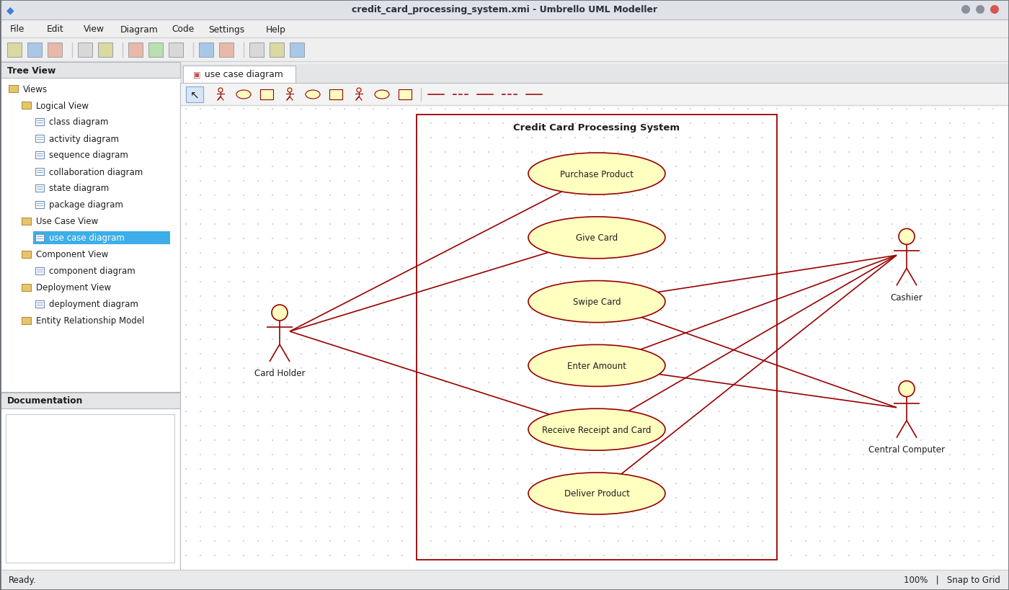
Use Case Diagram
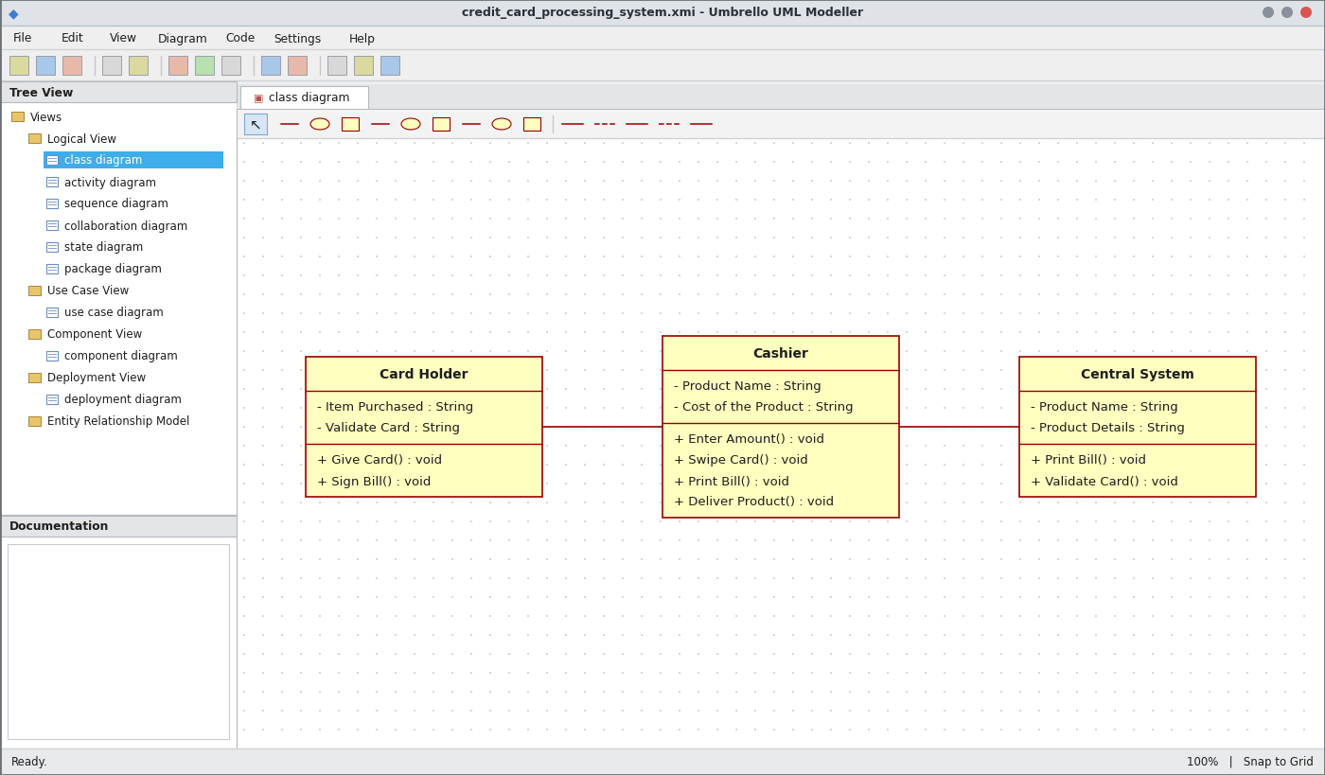
Class Diagram
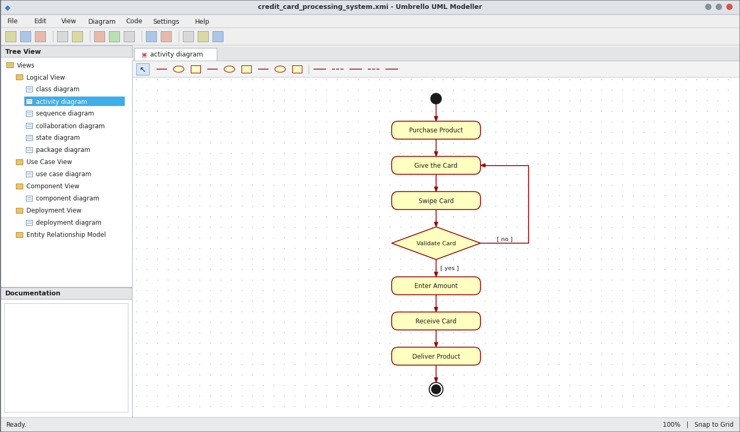
Activity Diagram
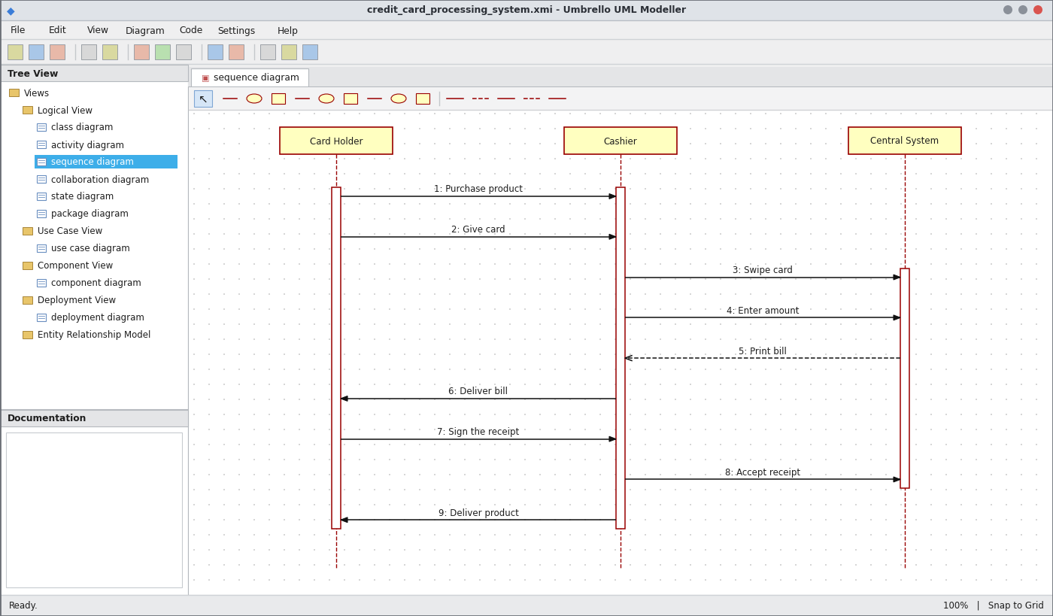
Sequence Diagram
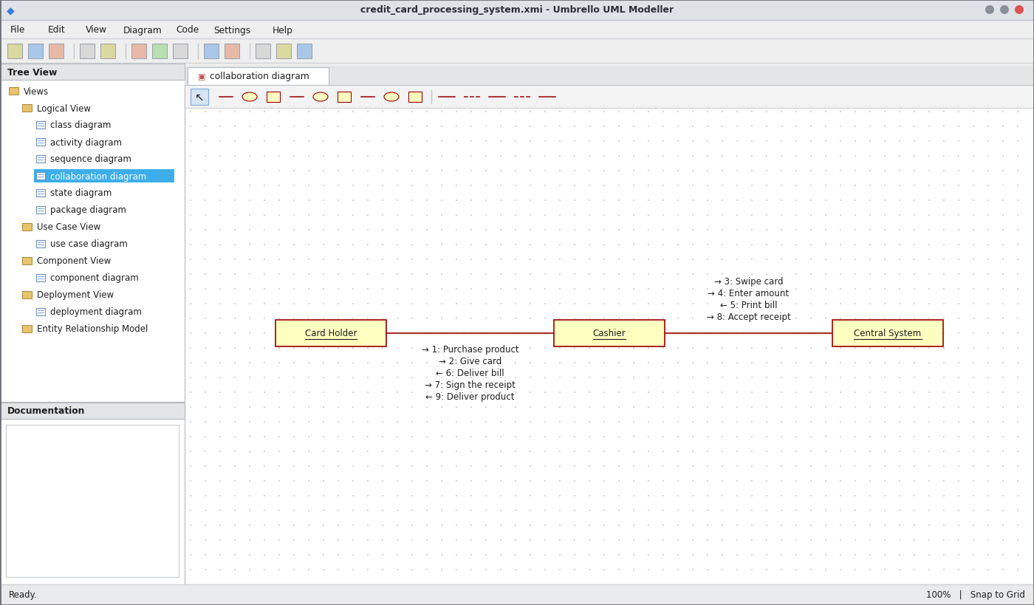
Collaboration Diagram
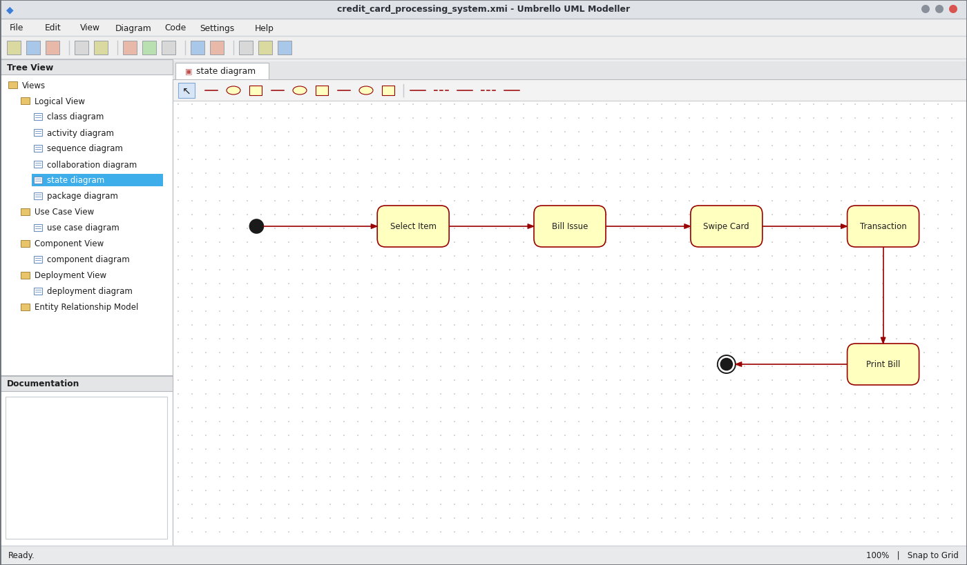
State Chart Diagram
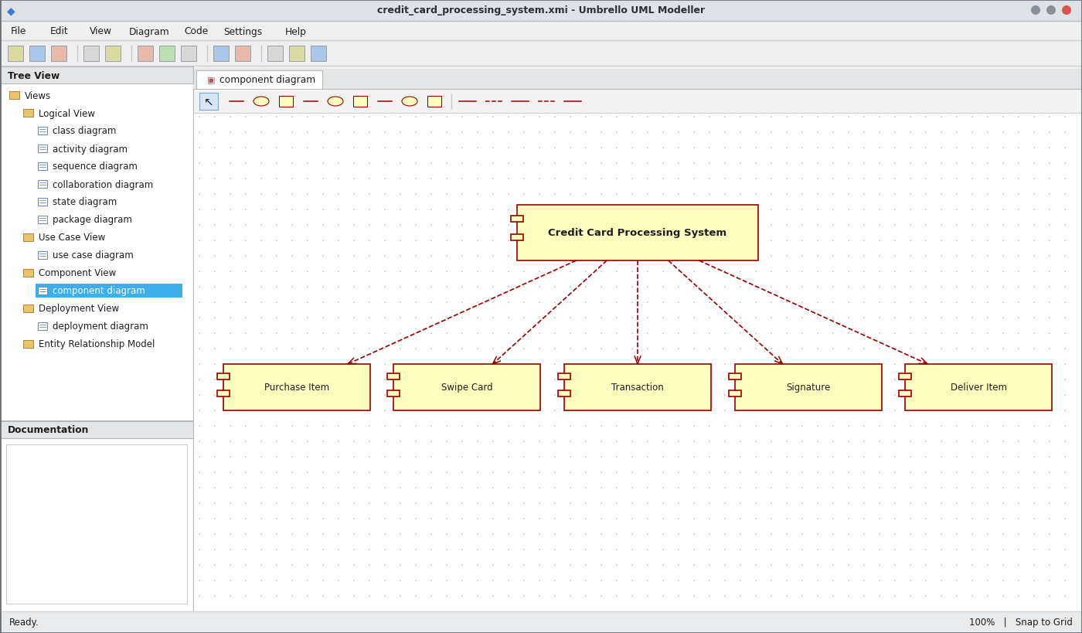
Component Diagram
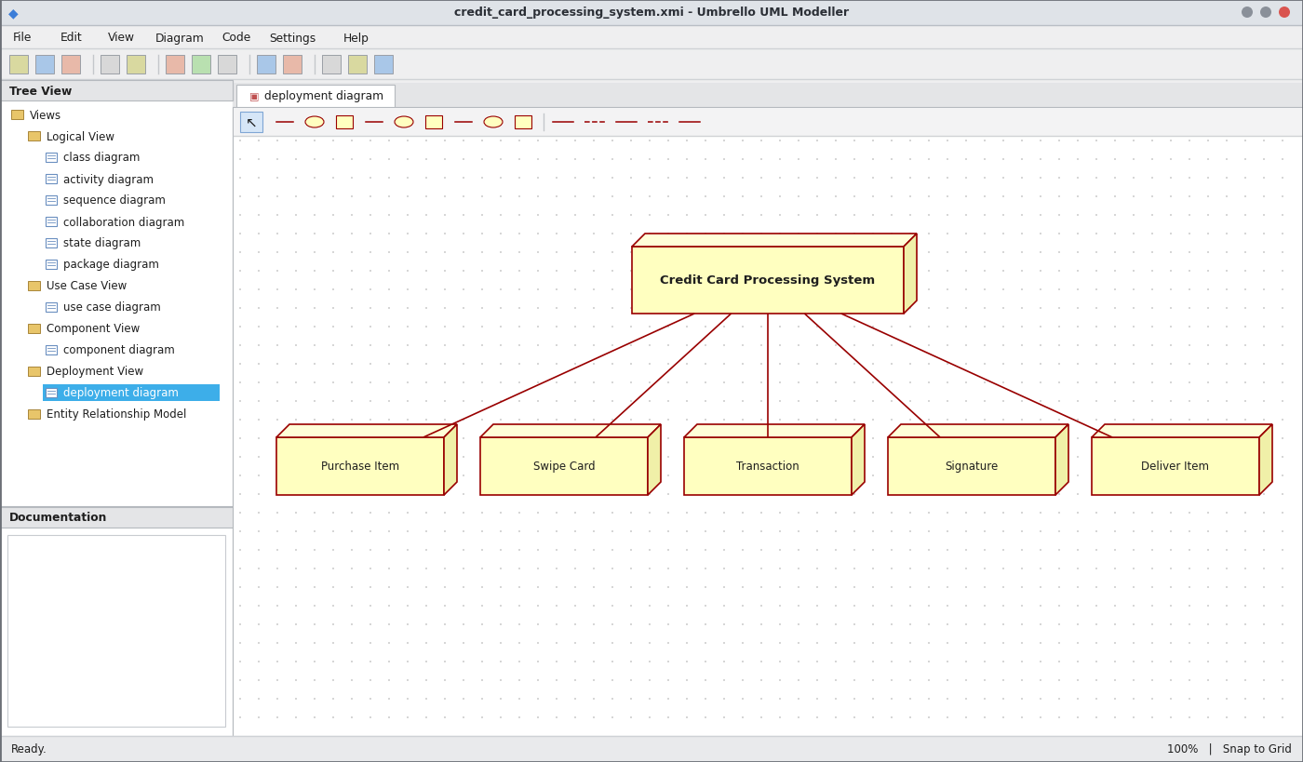
Deployment Diagram
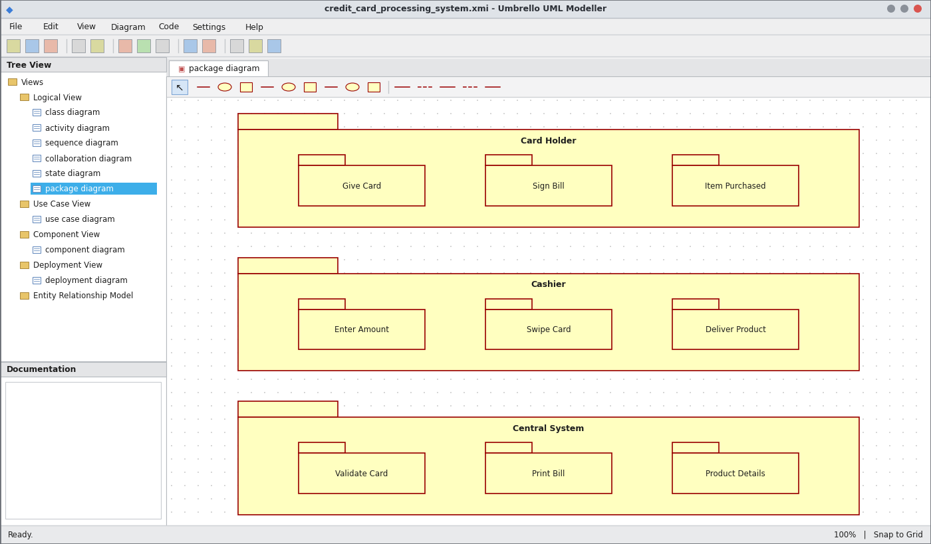
Package Diagram
WEBPAGE SCREENSHOT
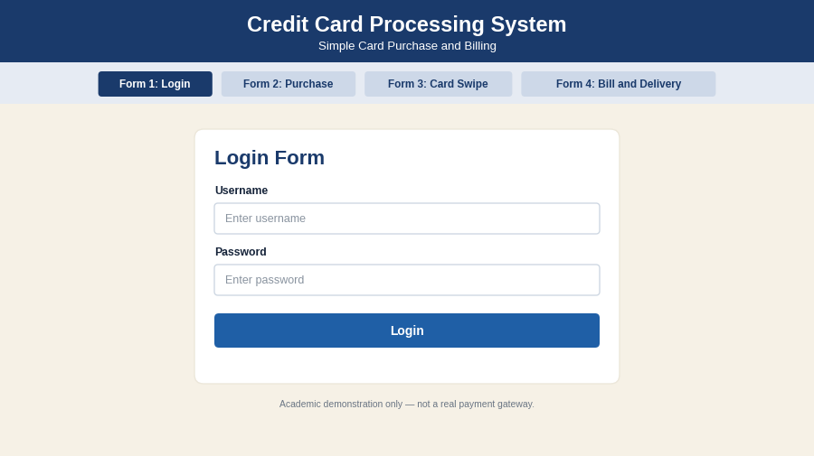
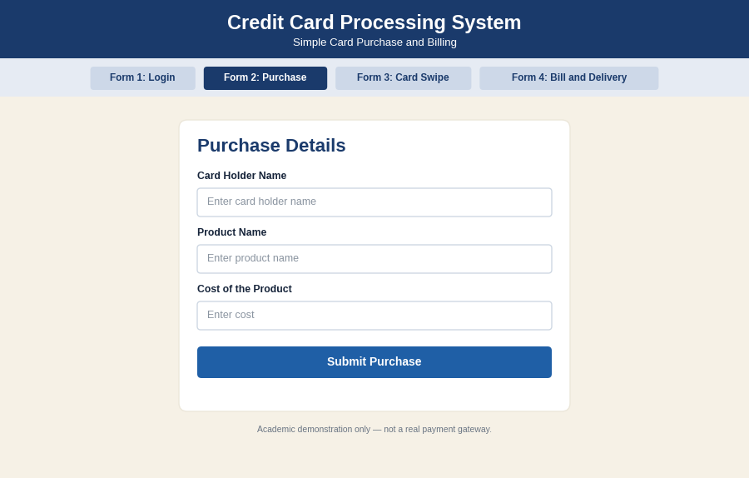
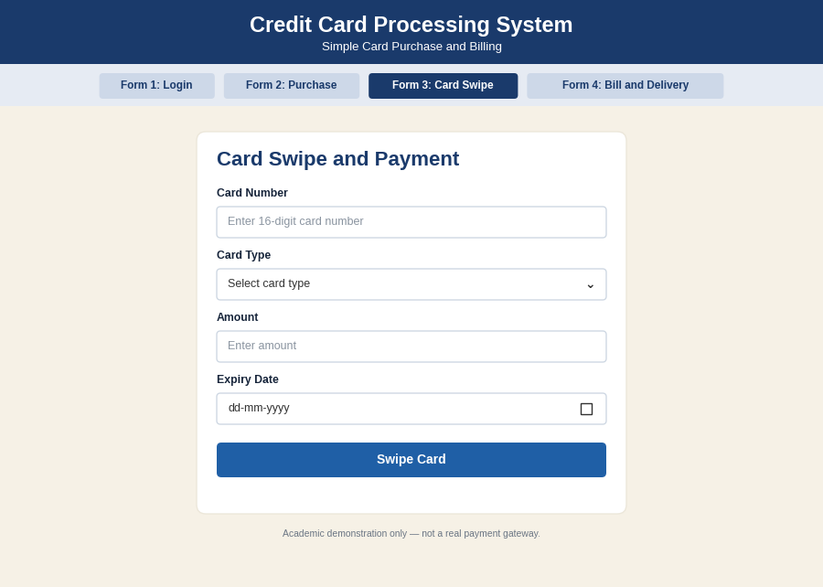
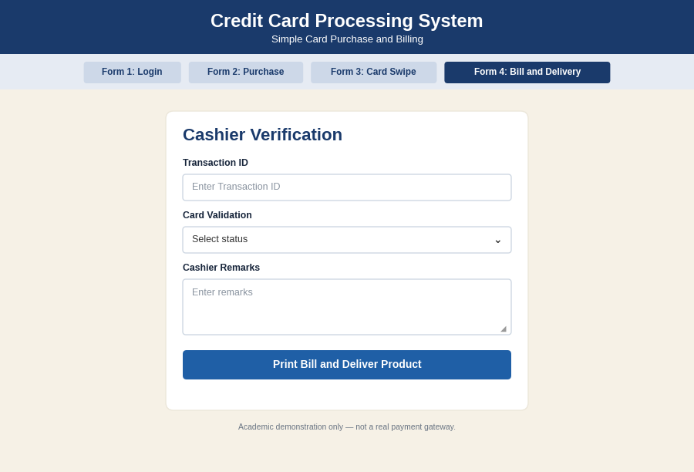
PSEUDO CODE
1. Purchase and Card Swipe
BEGIN
CARD HOLDER selects product and purchases item
CARD HOLDER gives card to cashier
CASHIER swipes card
SEND card details to central system
END
2. Card Validation and Amount Entry
BEGIN
CENTRAL SYSTEM validates card
IF card is valid THEN
CASHIER enters the amount
PERFORM transaction
ELSE
DISPLAY "Invalid card"; ASK for another card
ENDIF
END
3. Bill, Signature and Delivery
BEGIN
CENTRAL SYSTEM prints bill
CASHIER delivers bill to card holder
CARD HOLDER signs the receipt
CASHIER accepts receipt and returns card
DELIVER product to card holder
END

EX NO: 8 SOFTWARE PERSONNEL MANAGEMENT SYSTEM
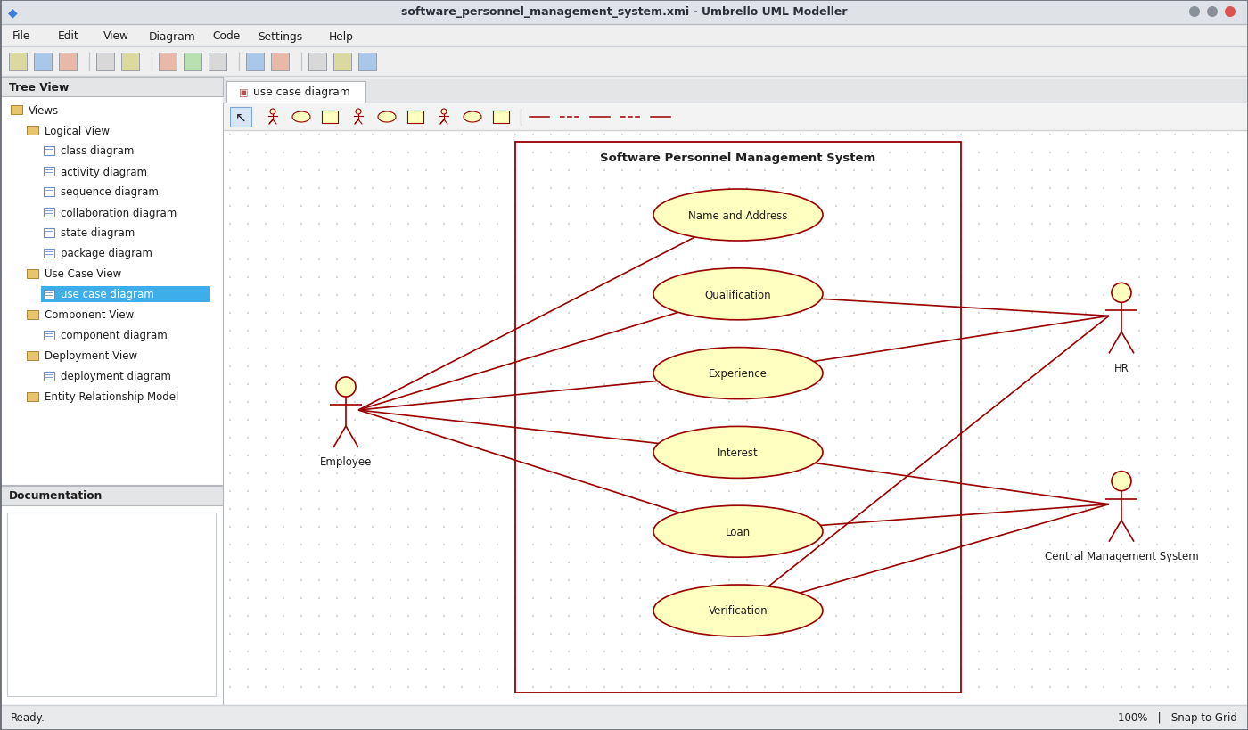
Use Case Diagram
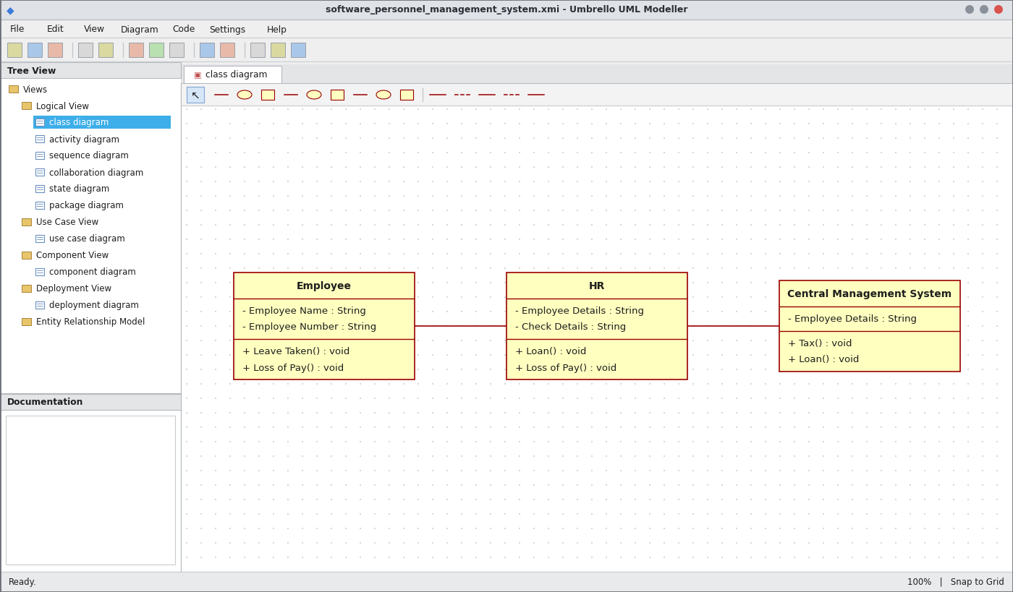
Class Diagram
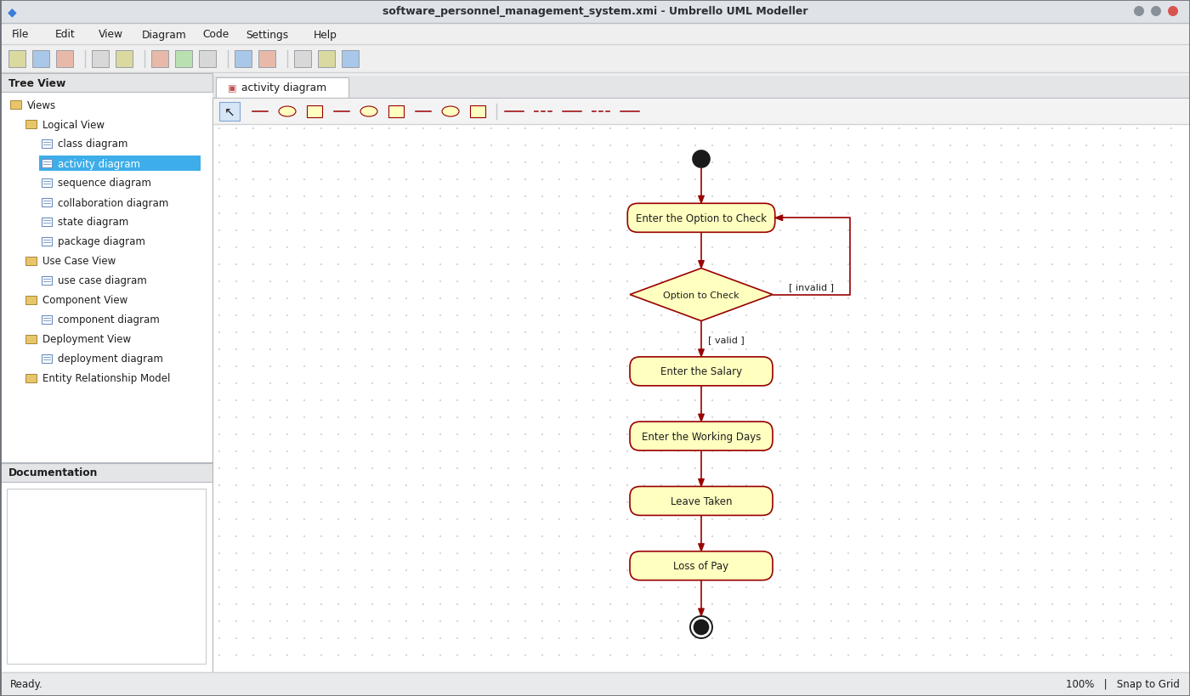
Activity Diagram
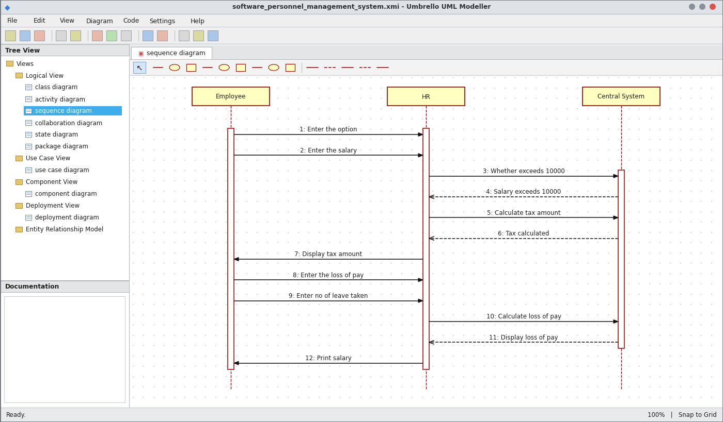
Sequence Diagram
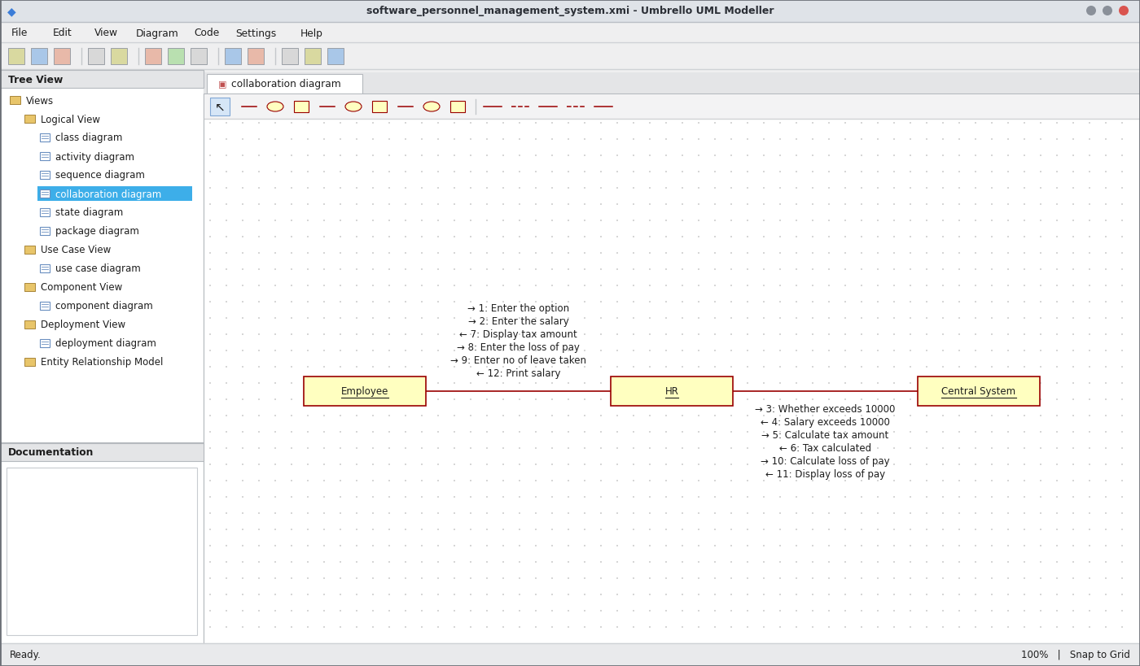
Collaboration Diagram
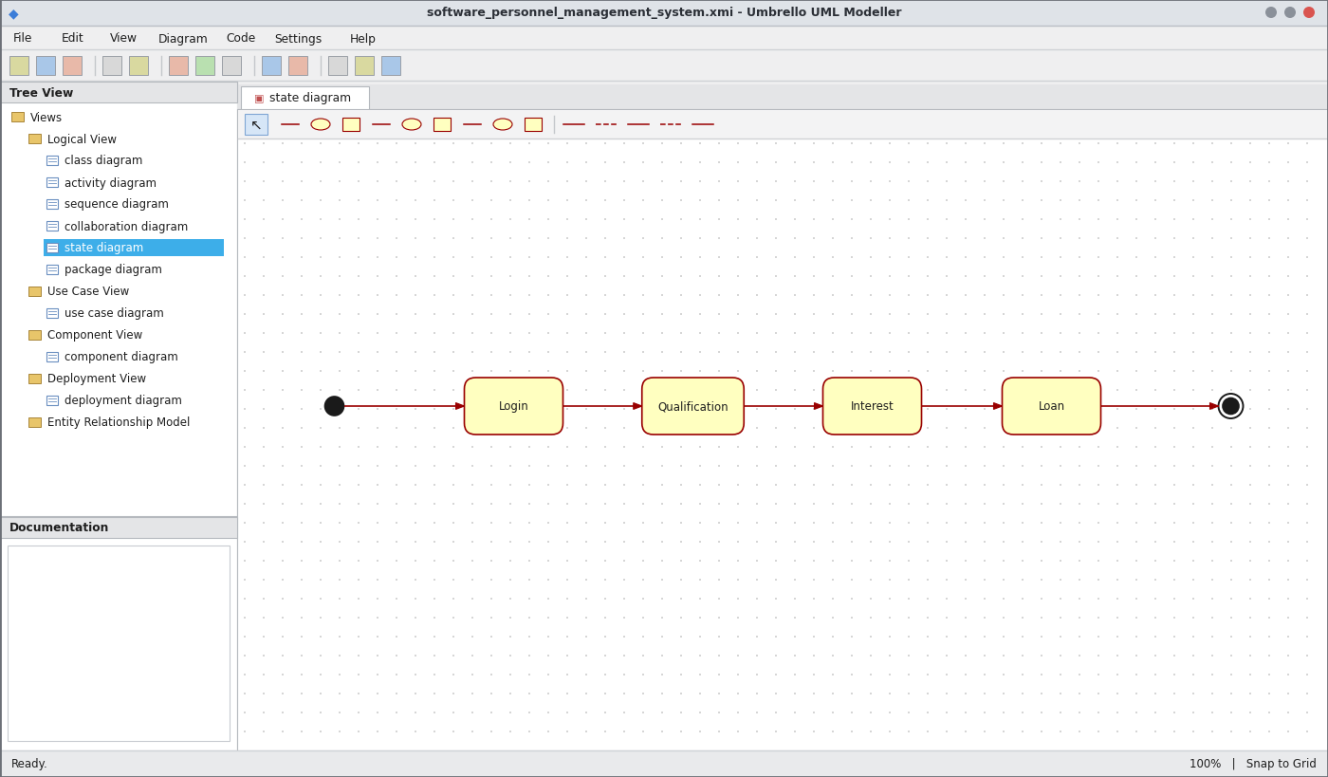
State Chart Diagram
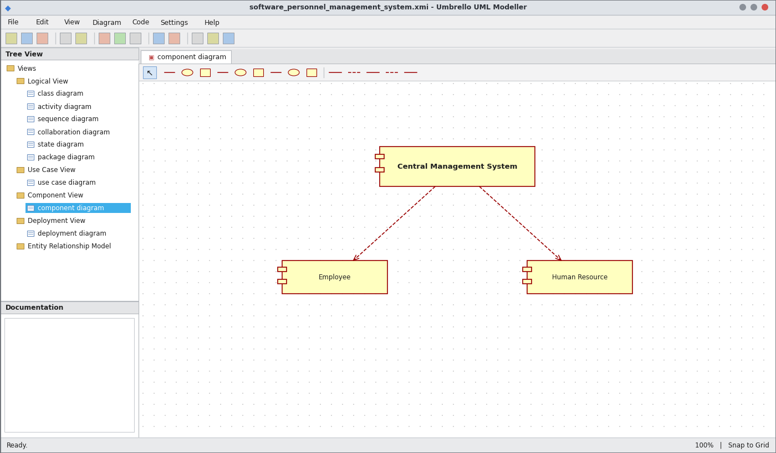
Component Diagram
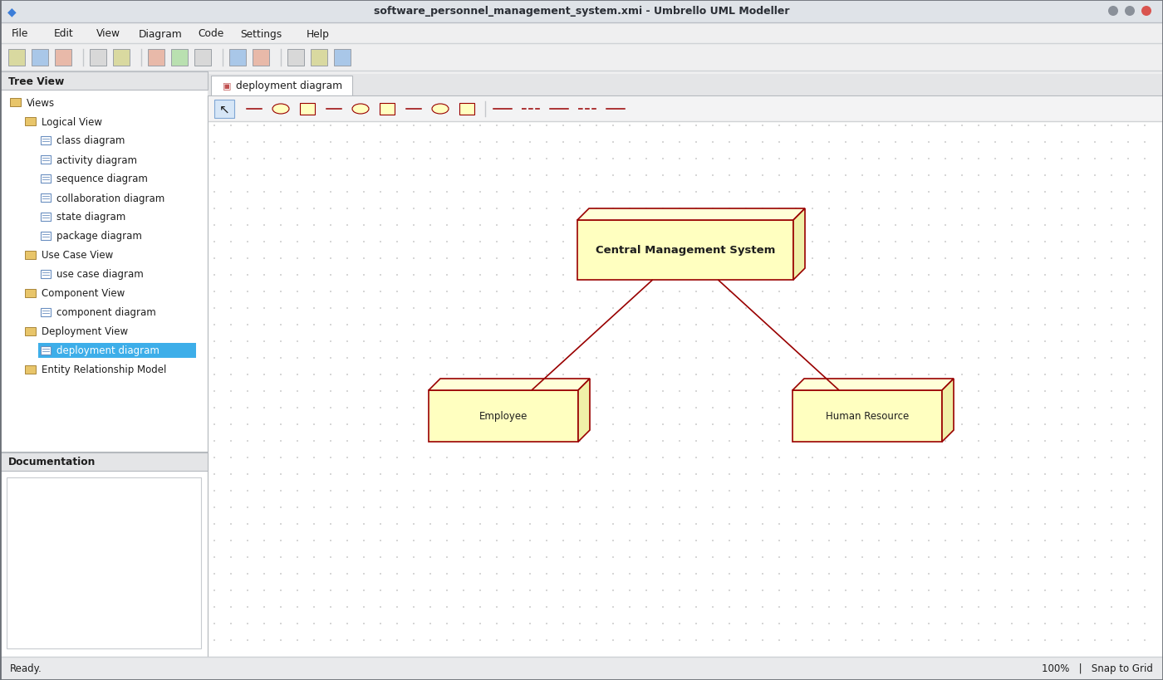
Deployment Diagram
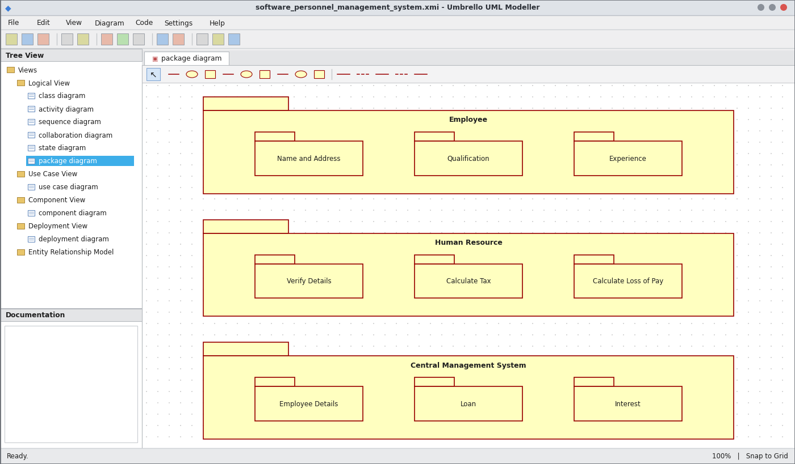
Package Diagram
WEBPAGE SCREENSHOT
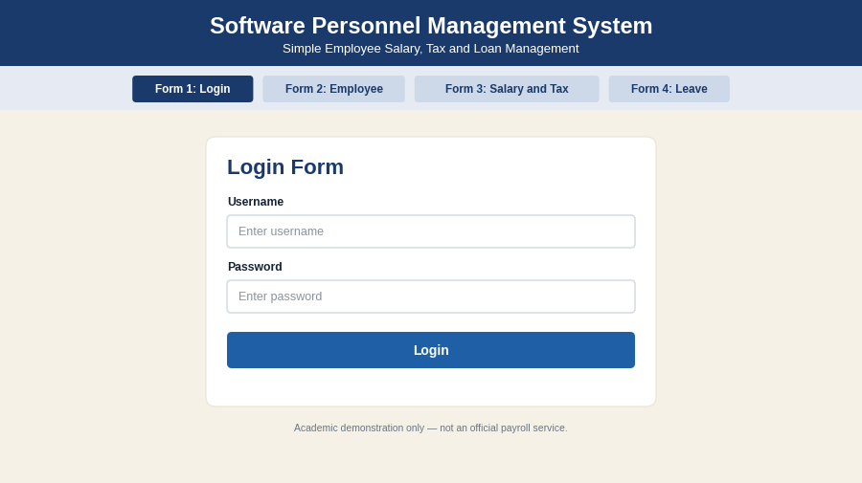
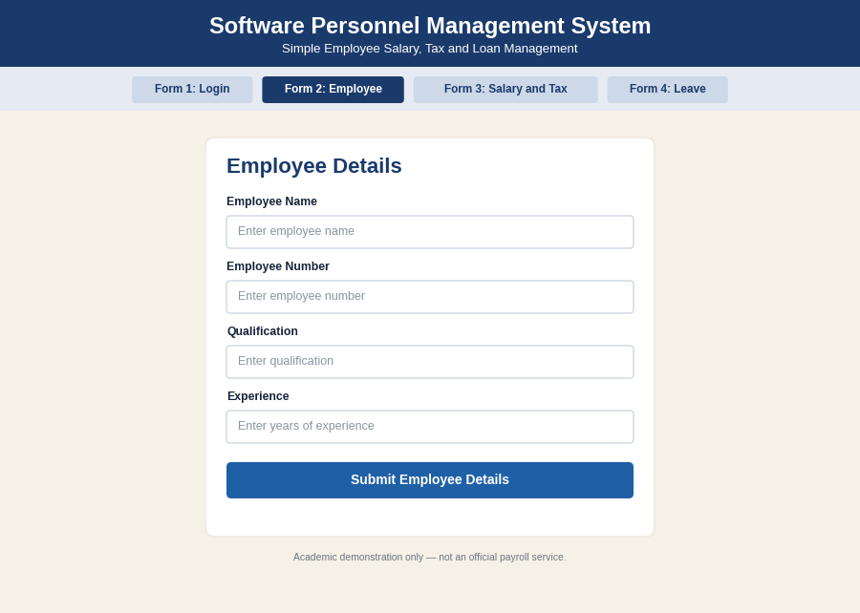
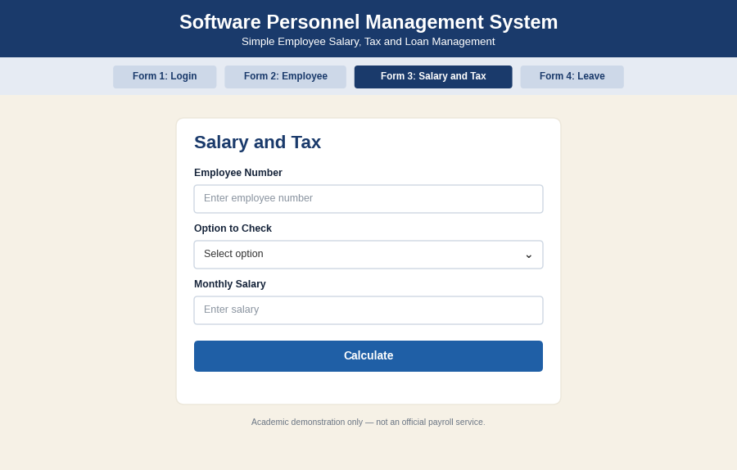
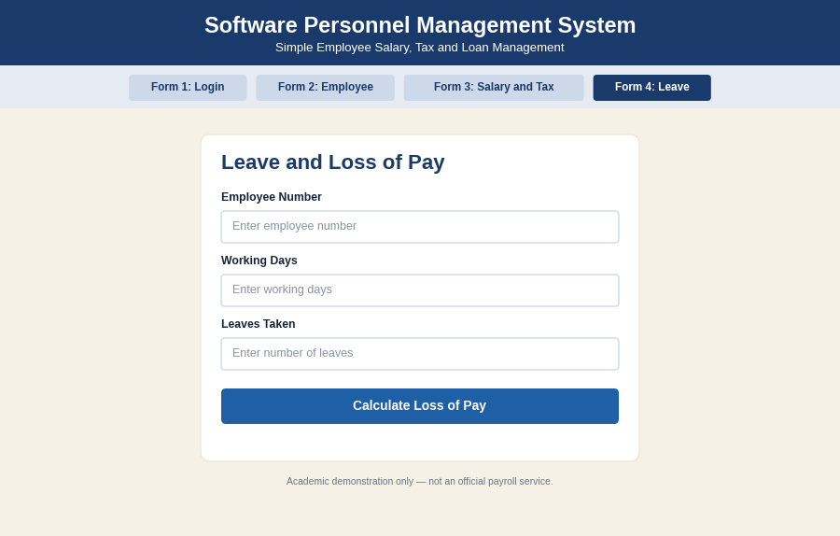
PSEUDO CODE
1. Employee Details and Option
BEGIN
EMPLOYEE enters name, address, qualification, experience
HR verifies the details
EMPLOYEE enters the option to check
IF option is valid THEN CONTINUE
ELSE ASK option again
ENDIF
END
2. Tax Calculation
BEGIN
READ salary
IF salary > 10000 THEN
CALCULATE tax amount
DISPLAY tax amount
ELSE
SET tax = 0
ENDIF
END
3. Loss of Pay and Salary
BEGIN
READ working days and leaves taken
CALCULATE loss of pay
net salary = salary - tax - loss of pay
DISPLAY loss of pay
PRINT salary
END

EX NO: 9 E-BOOK MANAGEMENT SYSTEM
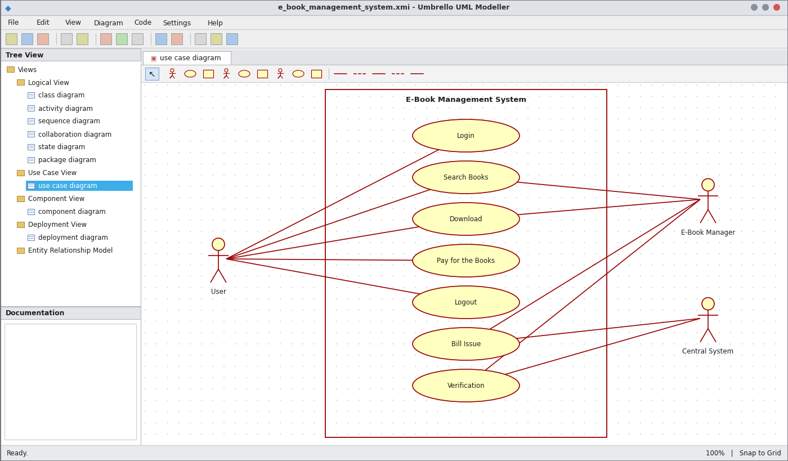
Use Case Diagram
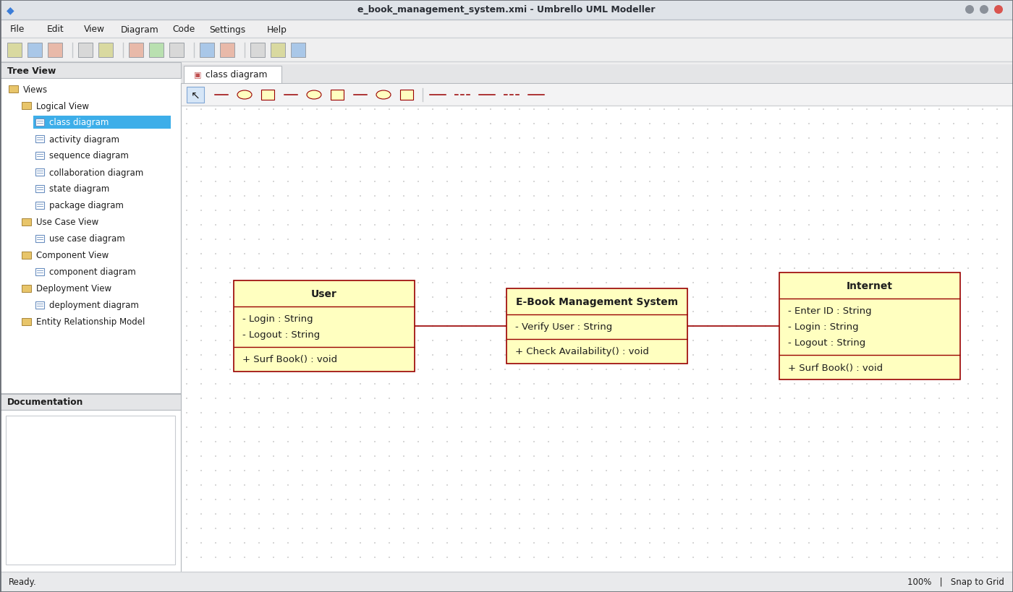
Class Diagram
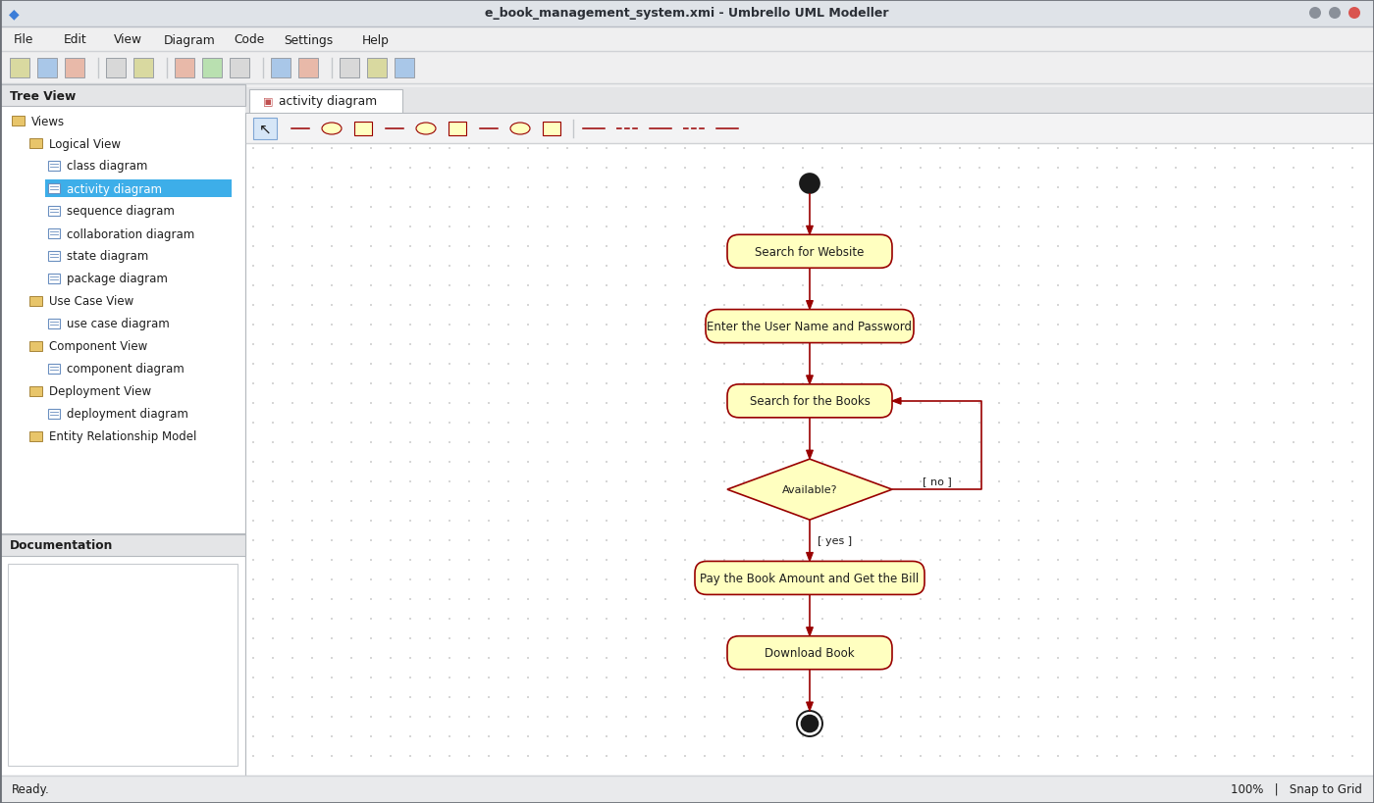
Activity Diagram
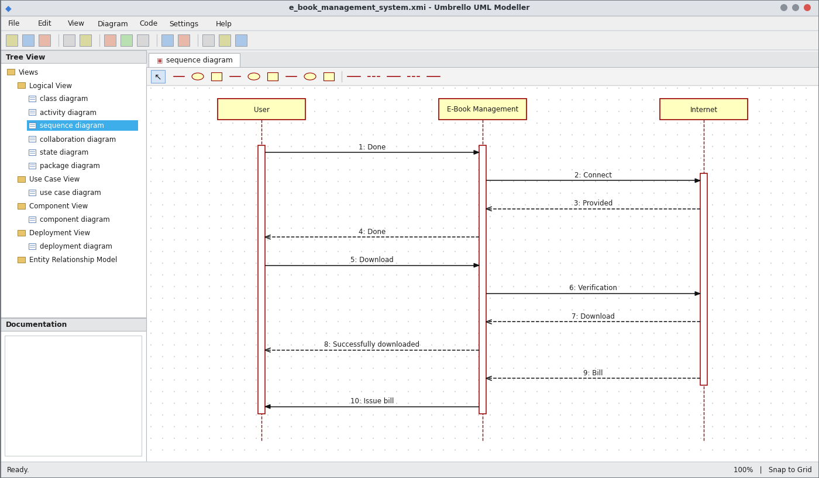
Sequence Diagram
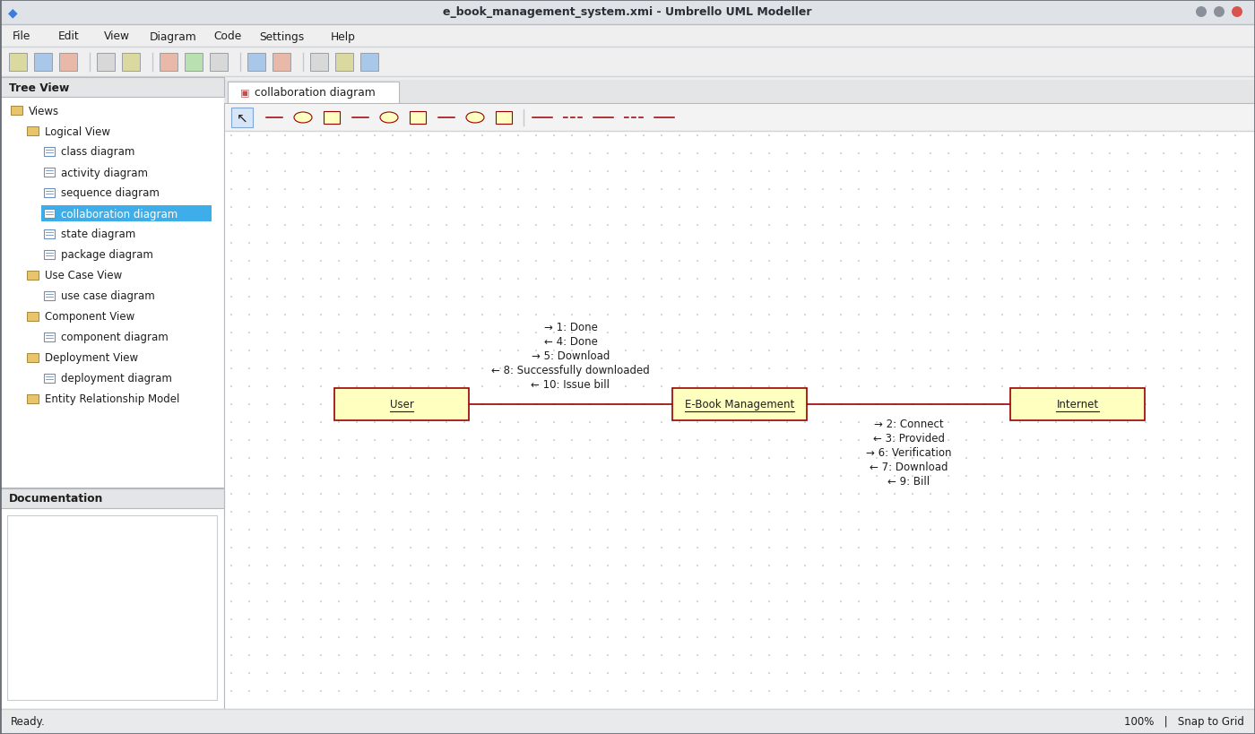
Collaboration Diagram
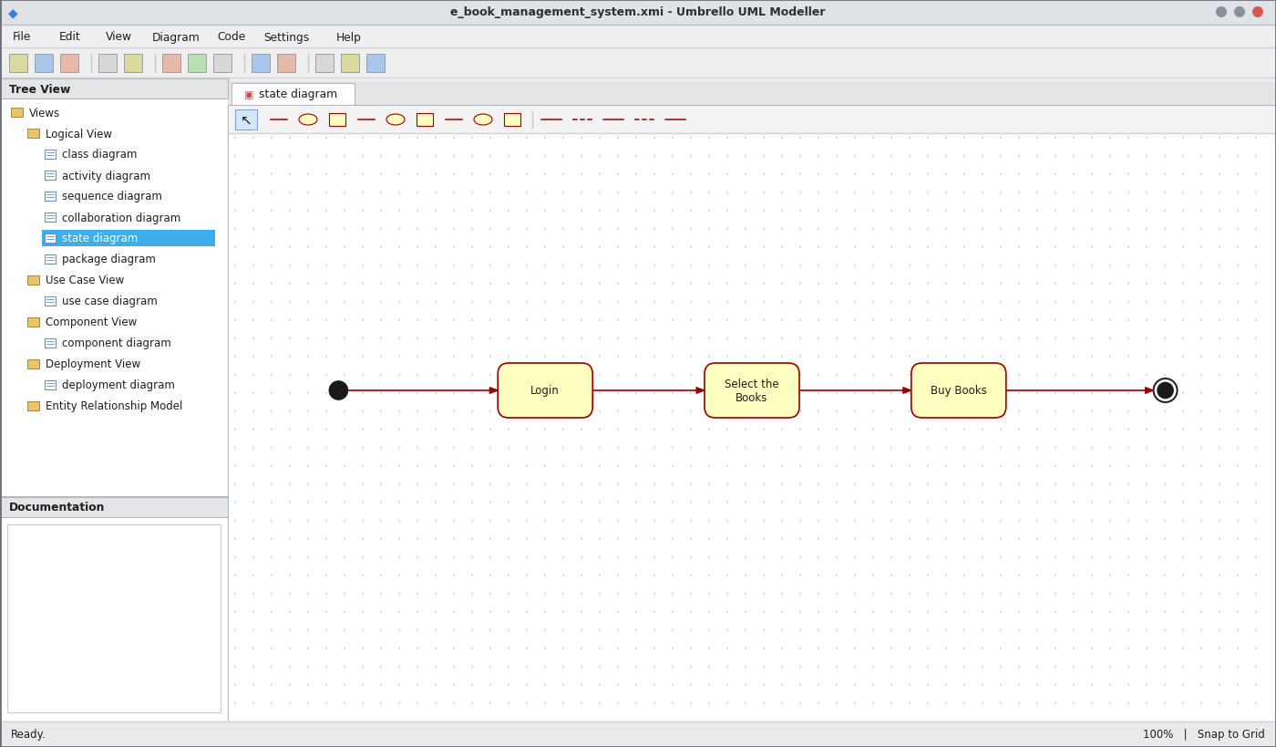
State Chart Diagram
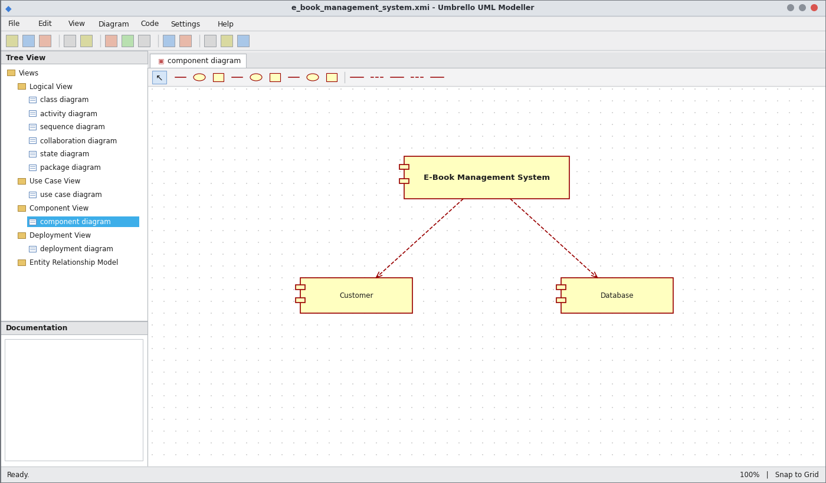
Component Diagram
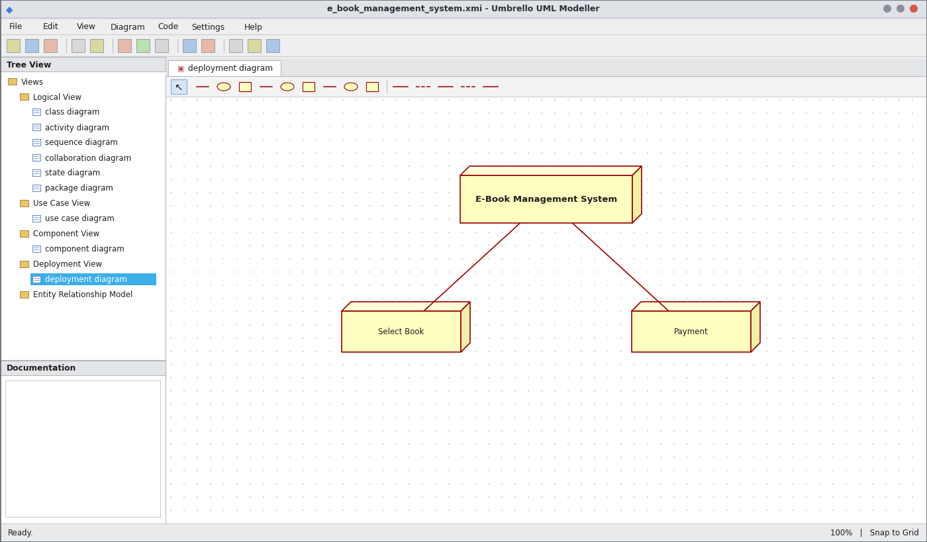
Deployment Diagram
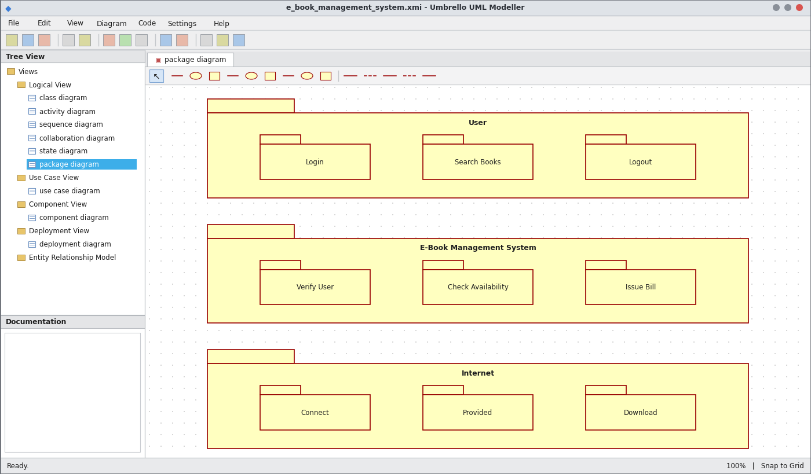
Package Diagram
WEBPAGE SCREENSHOT
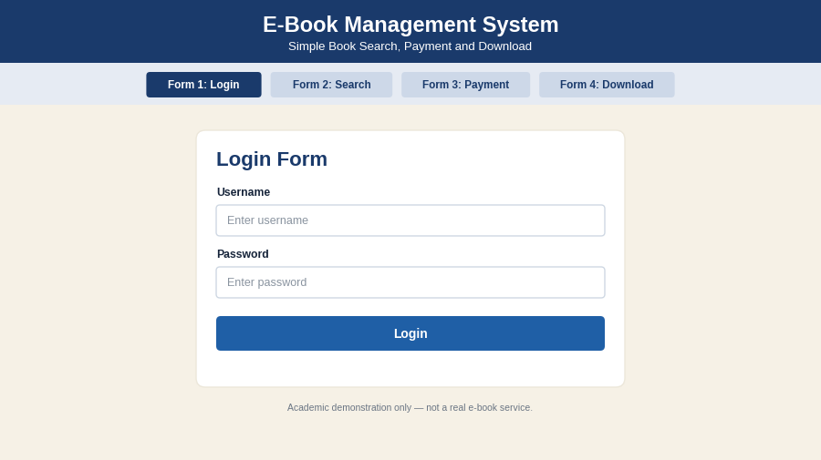
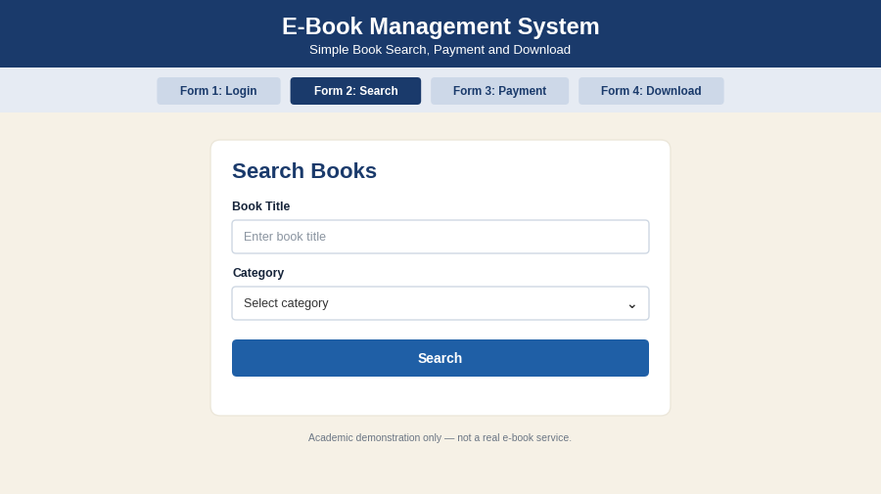
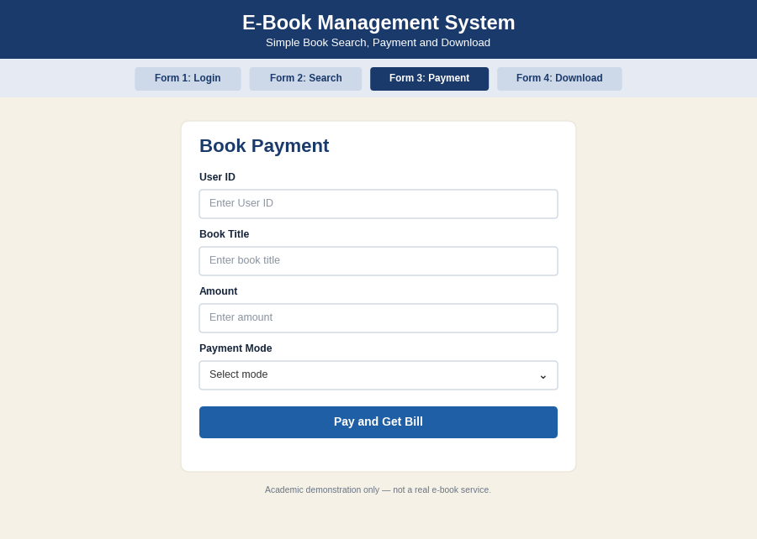
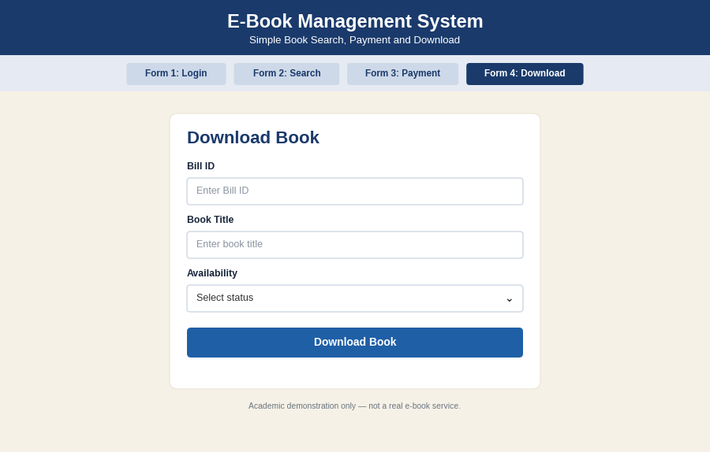
PSEUDO CODE
1. Login
BEGIN
USER searches for the e-book website
READ user name and password
IF login is valid THEN
CONNECT to internet
ELSE DISPLAY "Login failed"
ENDIF
END
2. Search and Availability
BEGIN
READ book title
SEARCH books in e-book management system
IF book is available THEN
SET available = TRUE
ELSE
DISPLAY "Book not available"; GOTO search
ENDIF
END
3. Payment, Bill and Download
BEGIN
IF available = TRUE THEN
READ payment amount
VERIFY payment
ISSUE bill
DOWNLOAD book
DISPLAY "Successfully downloaded"
ENDIF
END

